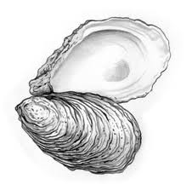
Oysters & Champagne Seminar Dinner
Max's Oyster Bar ~ West Hartford
An evening of oysters prepared several ways with champagne to accompany each course. Hosted by Executive Chef Scott Miller & Director of Wine Brian Mitchell. Thursday, November 8th, 6:30 PM
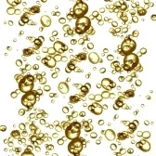

First Course
Bill Doyle’s Plymouth Rock Oysters
White Cranberry Mignonette | Gran Marnier “Caviar” | Quail Egg | Uni
Served with Gérard Bertrand, Cremant De Limoux, Brut, France, 2008
(a predecessor to Champagne)

Second Course
Washington State Willapa Bay Oyster Stew
Farmers Cow Milk | French Salsify | Truffle Crostini | Chervil
Served with Marguet, Brut Reserve Grand Cru, Champagne nv

Third Course
Norm Bloom & Sons Blue Point Oyster Dressing
Chestnuts | Smoked Pork Loin | Tasso Ham | Red Eye Gravy
Served with Paul Clouet, Brut, Champagne nv

Fourth Course
P.E.I Malpeque Oyster “Carpetbags”
Filet Mignon | Sauce Béarnaise | Oyster Mushroom Duxelles
Served with Delamotte, Brut Blanc de Blancs le Mesnil, 1999

Dessert Course
Chocolate Oysters
Chocolate Dipped Shells | Red Currant Mousse | Caramel “Mignonette”
Served with Tattinger, Prestige Rosé, Champagne nv

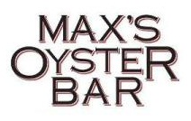
Please call (860) 236-6299 for Reservations – Seating is Limited to 20 guests
$100 per person, not including tax and gratuity

